StockPrices Head Output - Explanation

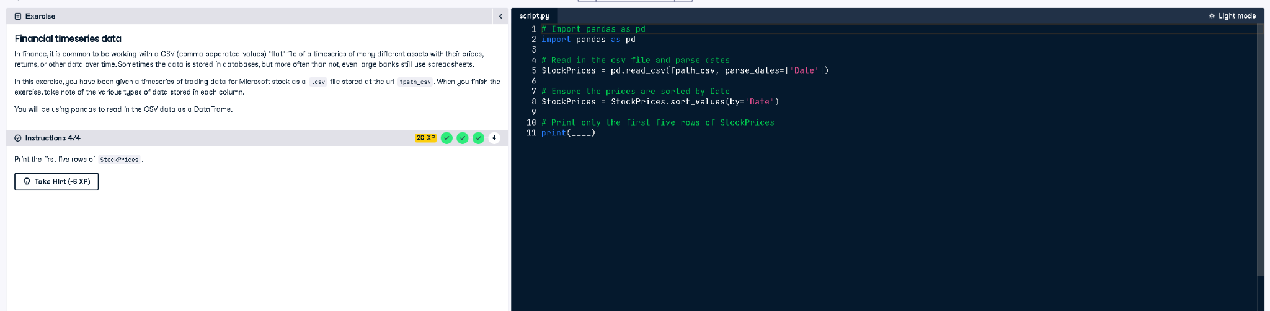

# Python Code

# Import pandas as pd  
import pandas as pd  
  
# Read in the csv file and parse dates  
StockPrices = pd.read_csv(fpath_csv, parse_dates=['Date'])  
  
# Ensure the prices are sorted by Date  
StockPrices = StockPrices.sort_values(by='Date')  
  
# Print only the first five rows of StockPrices  
print(StockPrices.head())

# Explanation (in simple words)

This code imports pandas, loads stock price data from a CSV file while converting the 'Date' column into date format. It sorts the data by the date column so it’s in chronological order. Finally, it prints the first 5 rows of the data using the head() function.